

June 13, 2025

**SuperStore Sales Dashboard**

**Table of Contents**

Contents

1. Introduction 3

2. Background and Objective 3

3. Methodology 4

3.1 Data Collection and Preparation: 4

3.2 Data Cleaning and Transformation: 4

3.3 KPI Calculation and Measures: 4

3.4 Dashboard Design and Visualization: 4

3.5 Visual Aesthetics and Layout: 8

3.6 Interactivity: 8

4 Recommended Actions: 8

5 Conclusion: 9

# Introduction

This report details the creation and functionality of an interactive Excel dashboard designed to provide comprehensive insights into sales performance. Utilizing data from the CSV file, the dashboard transforms raw Shopify transactional data into actionable key performance indicators (KPIs) and visualizations. The aim is to offer an at-a-glance view of sales trends, product performance, and operational efficiency, enabling users to monitor metrics in real-time and identify areas for improvement.

# Background and Objective

The project was initiated to leverage existing sales data, contained within an Excel-compatible CSV file, to build a robust and user-friendly analytical tool. The primary goal was to move beyond raw data lists and create a dynamic dashboard that simplifies complex sales information.

**Key objectives included:**

* 1. **Presenting Core Sales Performance Metrics:** To display critical KPIs such as Total Orders, Total Sales, Total Quantities Sold, Shipping Cost, Total Discount, and Outstanding Amount in an easily digestible format.
  2. **Analyzing Trends Over Time:** To visualize monthly trends for Total Sales, and Number of Orders done in each month to identify patterns and seasonal variations.
  3. **Breaking Down Performance by Category:** To analyze sales and order data across key dimensions like Warehouse, Shipping Province, Product, and Financial Status.
  4. **Enhancing User Interactivity:** To incorporate Excel's interactive features, such as slicers and a timeline, allowing users to filter and explore data dynamically for more granular insights.
  5. **Optimizing for Clarity and Aesthetics:** To design a dashboard layout that is clean, intuitive, and visually appealing, ensuring users can quickly interpret and act on the information presented.

# Methodology

The development of the Sales Performance Dashboard in Excel involved a structured approach, encompassing data preparation, KPI calculation, PivotTable and PivotChart creation, and dashboard design.

## Data Collection and Preparation:

* + 1. The project sample_superstore.csv file as the primary data source.
    2. **The raw CSV data was imported into Excel and then imported in the power BI**

## Data Cleaning and Transformation:

* + 1. The "Created at" column was verified and formatted correctly as a date to enable time-based analysis.
    2. Blank entries in the "Financial Status" column were identified and replaced with "paid" to consolidate related data points, ensuring accurate aggregation of financial statuses.
    3. The "order date" column was created which was separated as stated below.
    4. A new calculated column, "**year**, month and date" were added to the source Sales Data table. This column was created to compute the total sales and orders with respect to the date order.

## 3.3 KPI Calculation and Measures:

Multiple PivotTables were created, each dedicated to a specific set of KPIs or a single KPI for charting flexibility:

* + 1. **Summary Metrics:** Different measures regarding each KPI’s are generated separately. So that each measure can be used in making of individual charts.
    2. **Monthly Trends:** Separate measures were created for "Total Sales by month" (Sum of Total grouped by Created at), "No. of Orders by Month" (Count of Id grouped by Created at), and "Average Order Value by month" (using a PivotTable Calculated Field: = Total / Id). This separation ensured individual charting for each trend.
    3. **Categorical Breakdowns:** Individual Measures were set up for "Total Sales by Product ", "Order by Product segment", "Total Sales by Product", and "Order by category of each order ID".

## Dashboard Design and Visualization:

* + 1. **Dashboard:** A dedicated "Dashboard" sheet was created for the final presentation.

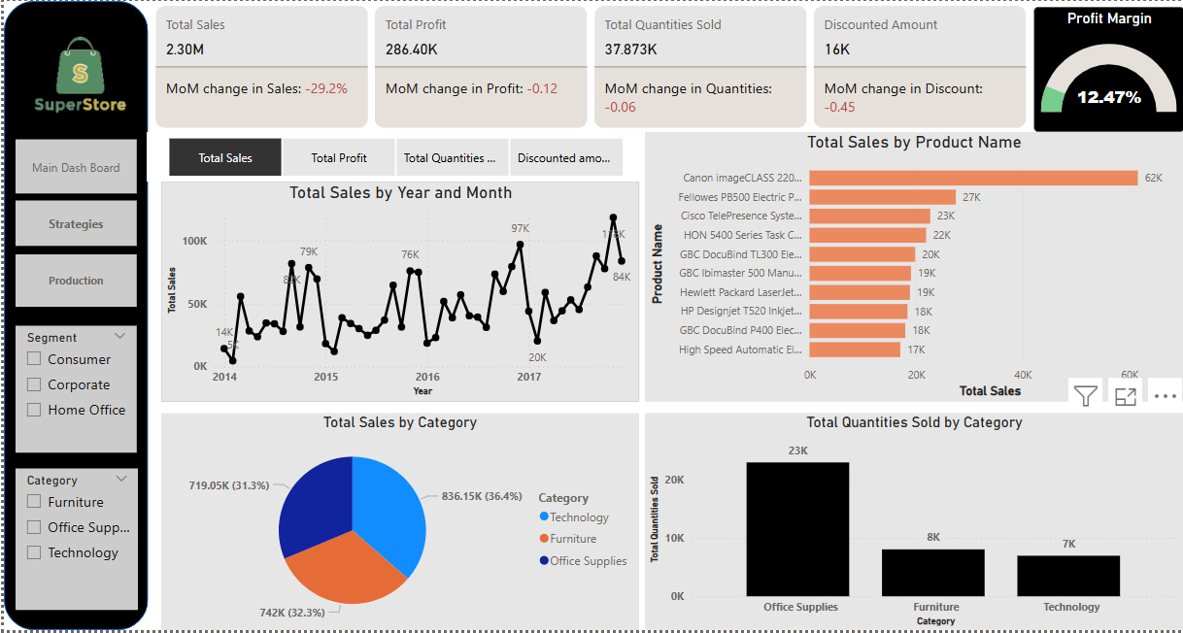

Figure 3.4.1 (Superstore Sales Dashboard)

* + 1. **Key summary KPIs:** Key Summary KPIs were extracted from their respective PivotTables and displayed prominently using linked cell references within custom-designed shapes, providing a "card" like visual.
    2. **Overall Sales Performance:** The total sales figure for the period is **$458,751.64**. This represents the cumulative revenue generated from all orders, providing a foundational understanding of the business's financial scale. Other key summary metrics include a **Total Orders** count of **2,471**, **Quantity Sold** of **2,808** units, **Total Shipping Cost** of **$36,962.65**, **Total Discount** applied of **$109,307.20**, and an **Outstanding Amount** of **$16,493.77**.

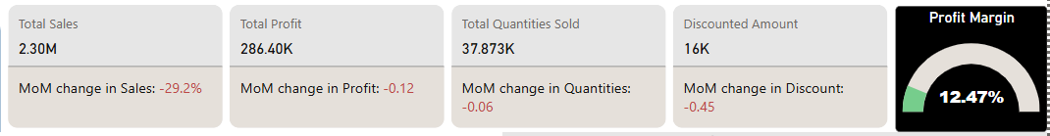

Figure 3.4.2 (Measures Created as KPI’s)

1. **Monthly Trends:** Measures were generated from each of the dates, including line charts for monthly trends and a timeline for interactivity.Over the period from **2024 to 2025**, the **Number of Orders By Month** shows a general upward trend through 2024, peaking towards the end of the year, and then fluctuating in 2025 with a peak in March and a subsequent dip. The **Average Order Value by Month** (as represented by the 'Average Value of Order' column) shows slight fluctuations, indicating consistent average transaction sizes despite variations in order volume.

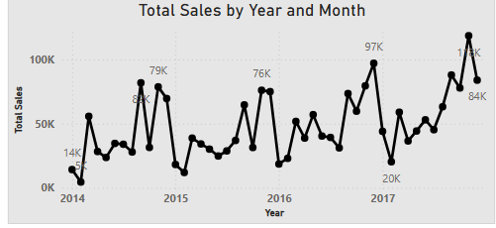

Figure 3.4.3.A (Monthly Trends)

* 1. **Product Performance:**
     1. Products Revenue by **Category**:
        1. **Furniture**: $391.05K.
        2. **Office Supply**: $363.9K.
        3. **Technology**: $406K.7.
     2. Top products by **Segment sales**:
        1. **Consumer**: $134.6K
        2. **Corporate**: $91.4K
        3. **Home Office**: $60.3K

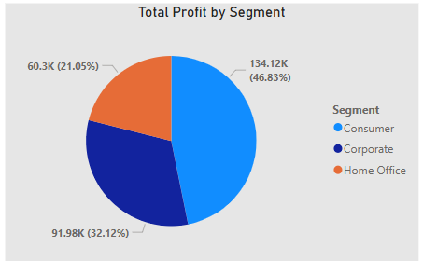

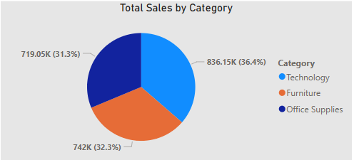

Figure 3.4.3.B (Product Categorical Breakdowns)

1. **Categorical breakdown on Quantities:** Measures were generated from each of the detailed Measures, including bar and column charts for categorical breakdowns.

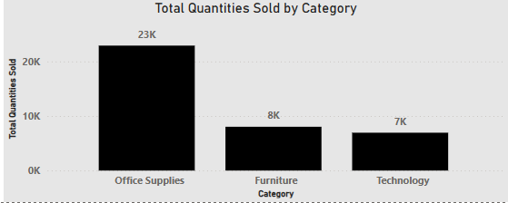

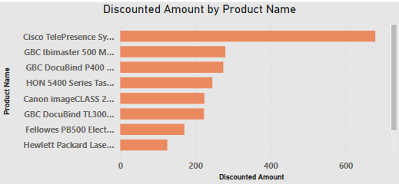

Figure 3.4.3.C (Quantities Categorical Breakdowns)

## Visual Aesthetics and Layout:

Timeline dashboard was designed with a clean, materialistic aesthetic, utilizing subtle background and shapes with soft shadows to give elements a sense of elevation. Charts were formatted with no fill or outline to integrate seamlessly with the underlying shapes. Consistent color palettes, clear titles, and readable fonts were applied throughout.

## Interactivity:

**Timeline** inserted for key dimensions (Created at (Year, Quarter, Month), and Slicers for Categories, segments, total sales, total quantities enabling dynamic filtering and exploration of data.

# Recommended Actions:

* + 1. **Increasing Profit Margin:** Overall profit margin can be increased by decreasing the profits on top selling products. In this way the overall profit for that product can be increased. For instance product named Canon Images has a top sales of $62K with a discount given of $1.8K. As the product is our top seller so that we can reduce its discount to increase profit margin on Canon images.
    2. **Production Increase of Top selling Products:** Increasing the production of the top selling products can also increase our profit with a margin of approximately 2%. For example, in data top profitable product is CICCO TelePresence. Increasing its production will eventually increase our profit.

# Conclusion:

The Power Bi Sales Performance Dashboard successfully provides a comprehensive and interactive platform for monitoring and analyzing key sales metrics. By transforming raw data into clear, visually appealing, and interactive insights, the dashboard empowers users to track performance in real-time, understand underlying trends, and make informed decisions to optimize sales strategies and operational efficiency. The use of Measure and the charts, and aesthetic design principles has resulted in a powerful and user-friendly analytical tool.